COMPOSING AN ABSTRACT FOR THE ANNUAL CONFERENCE OF THE MICROSCPOY SOCIETY OF TAIWAN

WEN, Cheng-Yen(溫政彥),¹ CHAO, Shih-Chun(趙士鈞),¹ TSAI, Yun-Yi(蔡昀嶧),¹ and CHANG, Ren-Jie(張仁頡)¹

¹Department of Materials Science and Engineering, National Taiwan University, Taipei, Taiwan

This document gives formatting instructions for authors preparing the proceeding abstract. The page size of the abstract is A4, all margins must be set as 2.54 cm (1 inch). The abstract contains two pages: page one must be composed of text only; page two comprises only figures and tables. The font of the entire document should Times New Roman font - the title is of 14 pt. bold type, and the text of 12 pt. regular font. Please note that all drawings, figures, and tables must be electronically inserted into the paper, as shown in Figure 1. Figures and tables must be numbered using Arabic numerals.

References may be included in page one [1], with the same reference styles as shown below.

Abstract is due on June 23, 2013.

References
- R. W. K. Honeycombe, Metall. Trans. A. 7 (1976) 915.

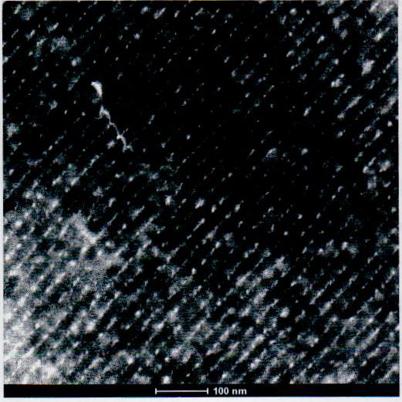
Figure 1. Sample figure for the abstract. Figure captions must be in 12 pt. regular
font and include panel labels and scale markers as necessary.

